User Guide

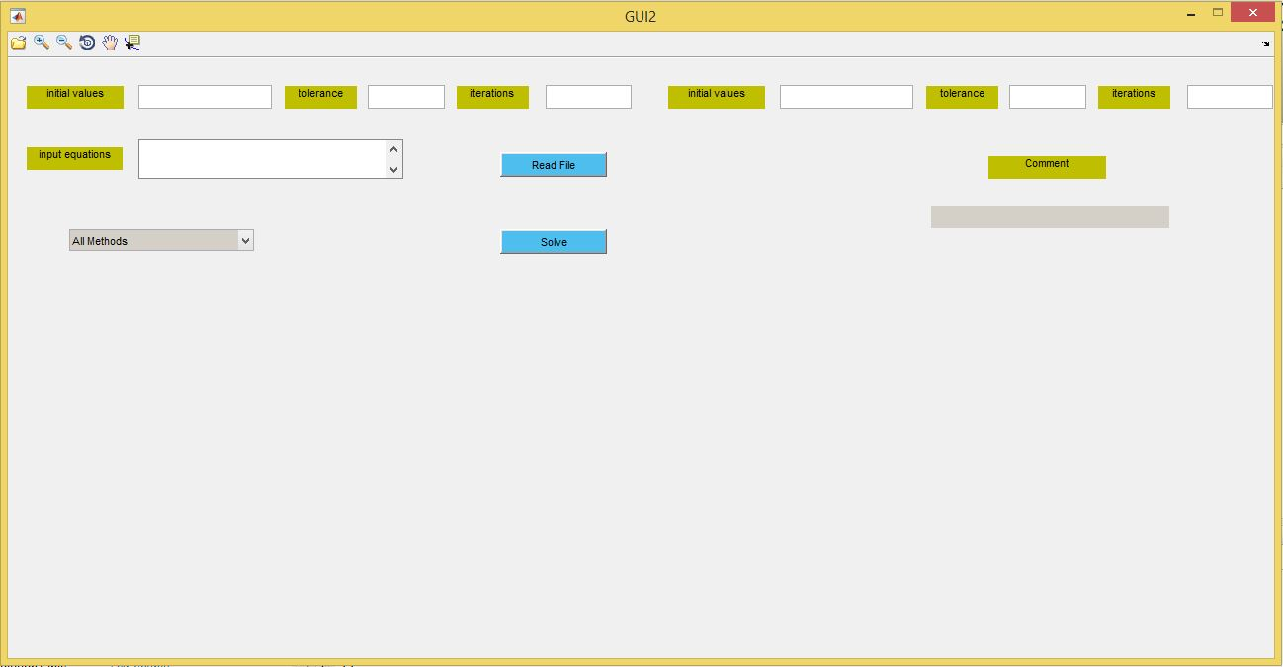

GUI has some fileds and buttons as viewed in the photo , each one has a meaning or a function :

1. Input equations : user can enter input equations here which he want to solve , it can have spaces or tabs but must be in valid format containing x1,x2,…..,xn and their coefficients like :

(x1+x2+2\*x3 = 3 or x1 -2\*x2 +2\*x3 = 3)

1. Drop down list : user can select the desired method he wants to solve linear system using it by just selecting it
2. Initial value : user can enter initial value here in case of using iterative methods (it is only visible and able to be used in case of selecting an iterative method from drop down list options , otherwise it will be invisible)

(Default value = [0,0,0,……] n zeros)

1. Tolerance : user can specify tolerance / Absolute error which is allowed in the final solutions of x1,x2,…,xn to increase accuracy

(Default value = 0.00001)

1. Iterations : user can specify maximum number of iterations allowed it iterative method if he cares more about running time versus accuracy

(Default value = 50)

1. Initial value , tolerance and iterations in the right half side like the mentioned above but it is used to the second iterative method

(Jacobi iterative) in case of using All Methods, otherwise it will be invisible always and we use the ones in the left half side only .

1. Read File Button : allow user to choose input file (extension : “.txt”) to read parameters and input equations from it , the input file must be in valid and fixed format :

* The first line must contain number of equations we want to solve .
* The n next line each one will contain an equation till finishing all the equations.
* The next line don’t have any fixed format but for flexibility we make it (“key name”) then next line you can write (“key value”)

for example :

{

3

x1+x2+x3 = 3

x1+2\*x2+x3 = 4

x1+2\*x2+3\*x3 = 4

initial

1 2 1

tolerance

0.00004

iterations

20

}

1. Solve Button: to solve equations with the given parameters, if the parameters are valid then we will execute method call, otherwise we will show a message “invalid input” in comment field, if inputs are valid then we will look for solutions if we can get it then display the solutions in an appropriate view depending on the selected methods like (tables, matrix representation) we will see that in sample runs section.

Note: after solving using any method we output the solutions in a text file which is located in same directory where running GUI exists.

Sample runs

First Example

Inputs {

x1+x2+x3 = 2

x1+2\*x2+x3 = 3

x1+5\*x2+2\*x3 = 6

}

Solving using Gauss Elimination with showing every step using Next and Previous Buttons which are allowed and visible only in Direct Methods

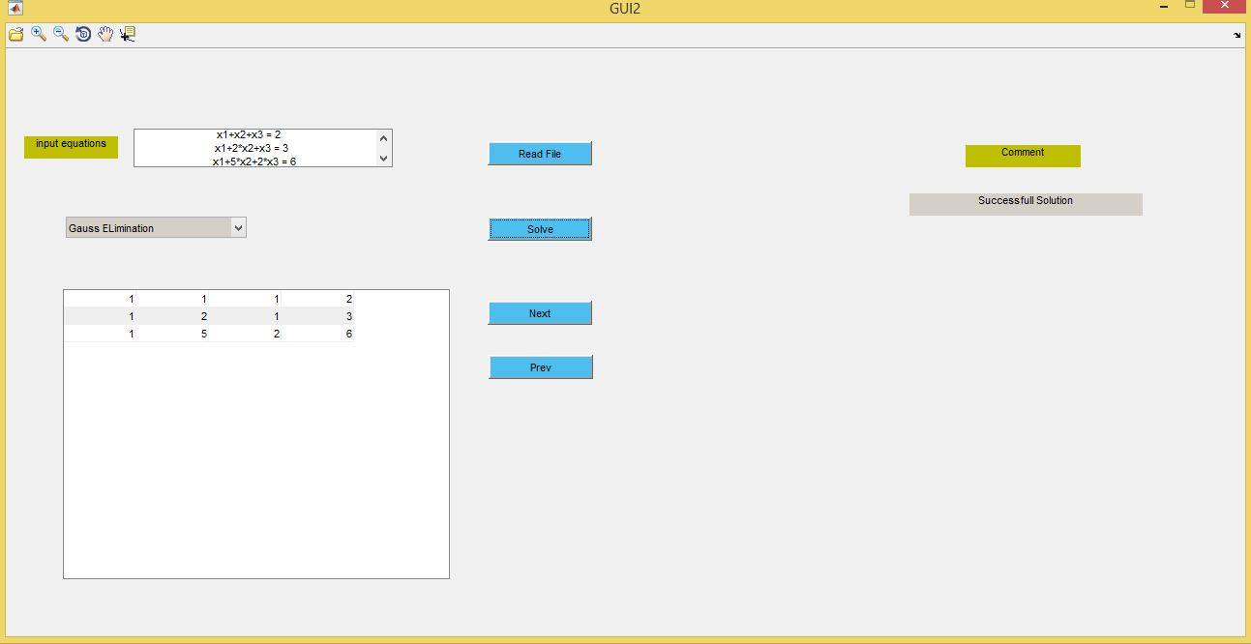

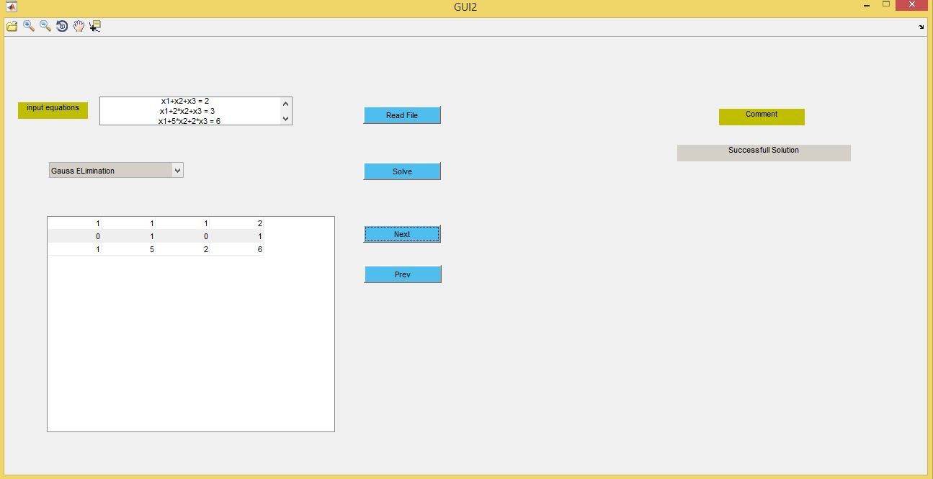 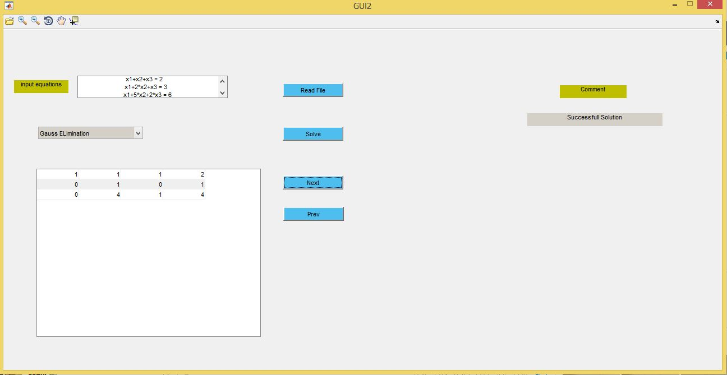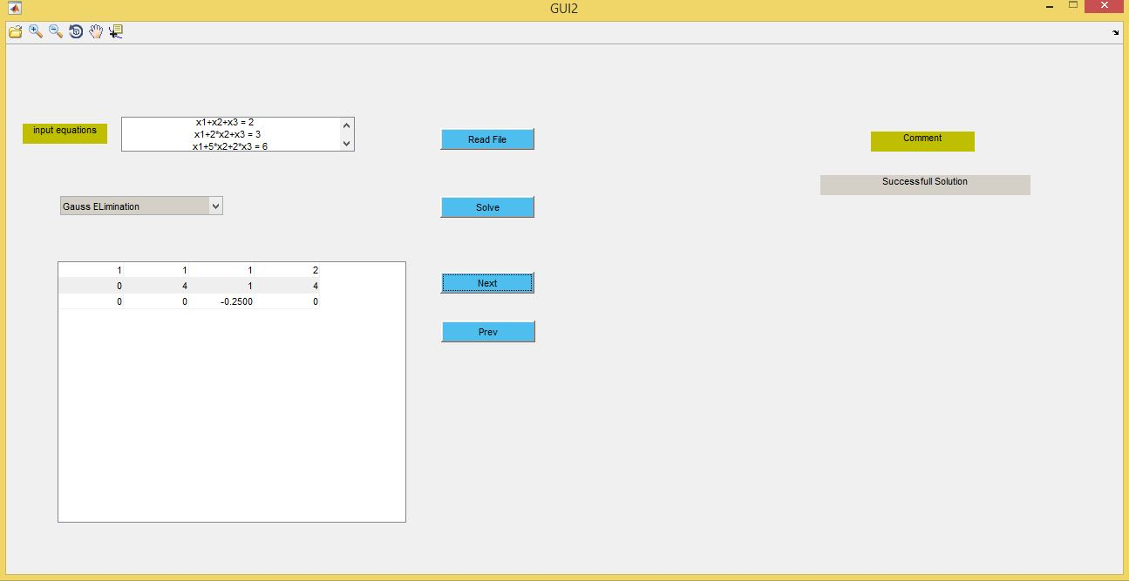 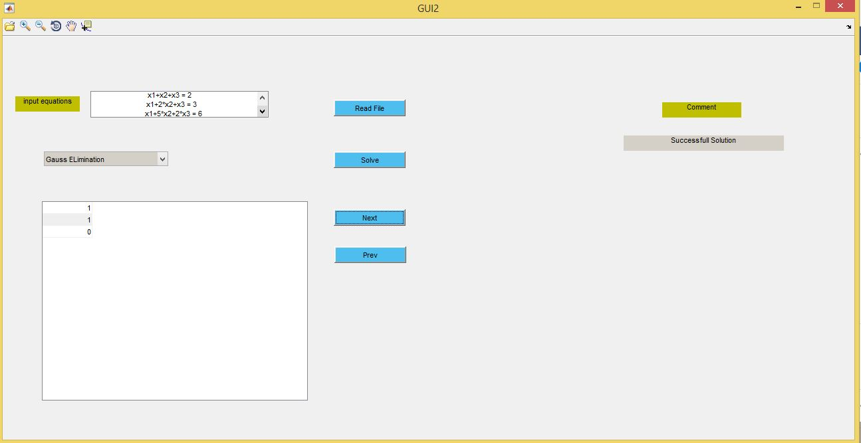

The output will be :

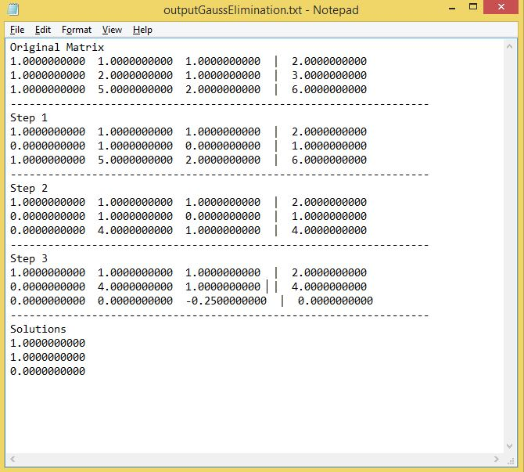

Second Example

Inputs {

x1+x2+x3 = 2

x1+2\*x2+x3 = 3

x1+5\*x2+2\*x3 = 6

}

Solving using Gauss Seidel with initial value = [0.5 , 0 , 0.5]

Output data will be viewed in table format .

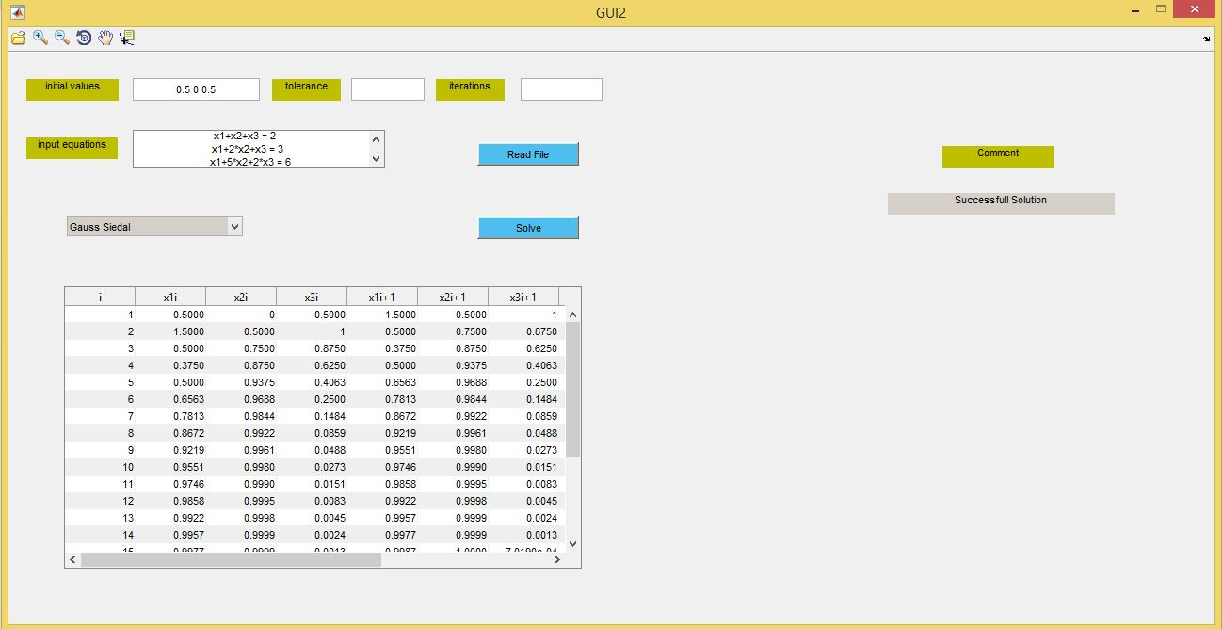

The output file will be :

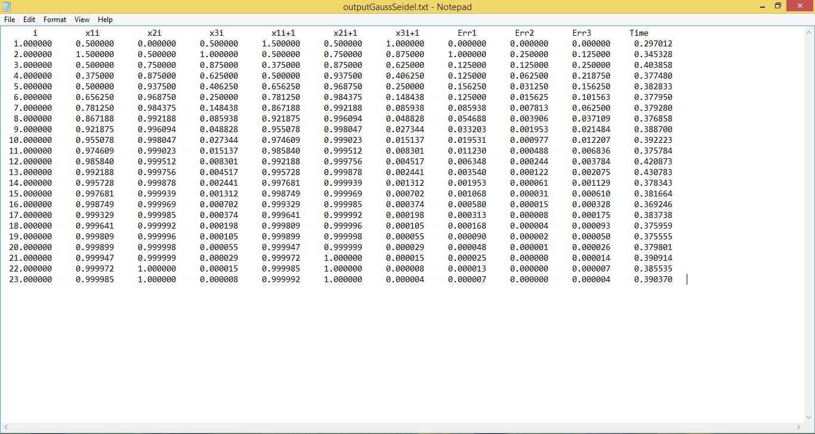

Third Example

Inputs {

2\*x1+x2+x3 = 2

2\*x1+6\*x2+x3 = 3

x1+4\*x2-2\*x3 = 6

}

Solving using All Methods with initial value = [0.5 , 0 , 0.5]

For Gauss Seidel Method.

The Curves between number of iterations and approximate root at this iterations will be plotted in case of using all methods and will be like :

Curve for x1

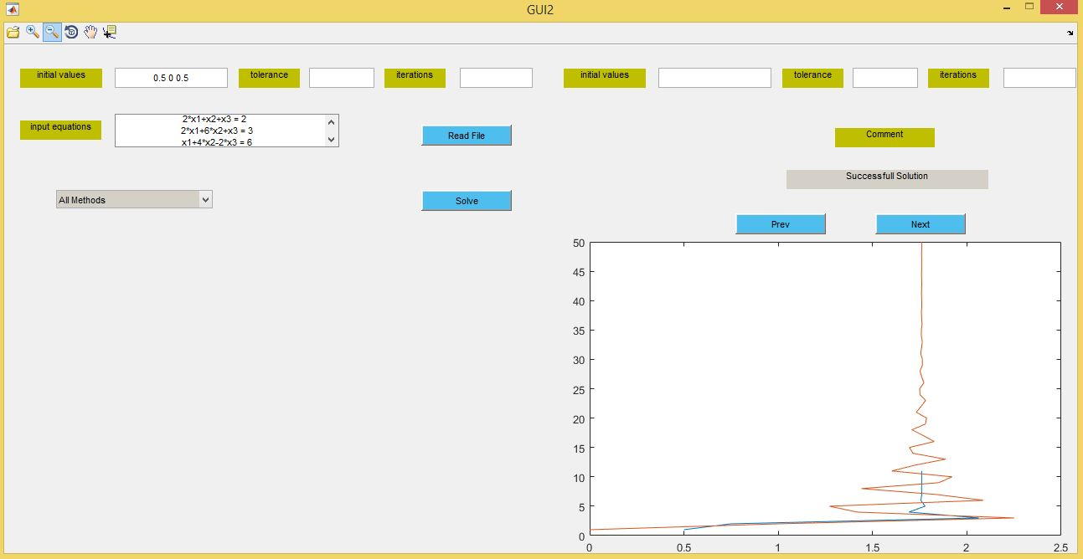

Curve for x2

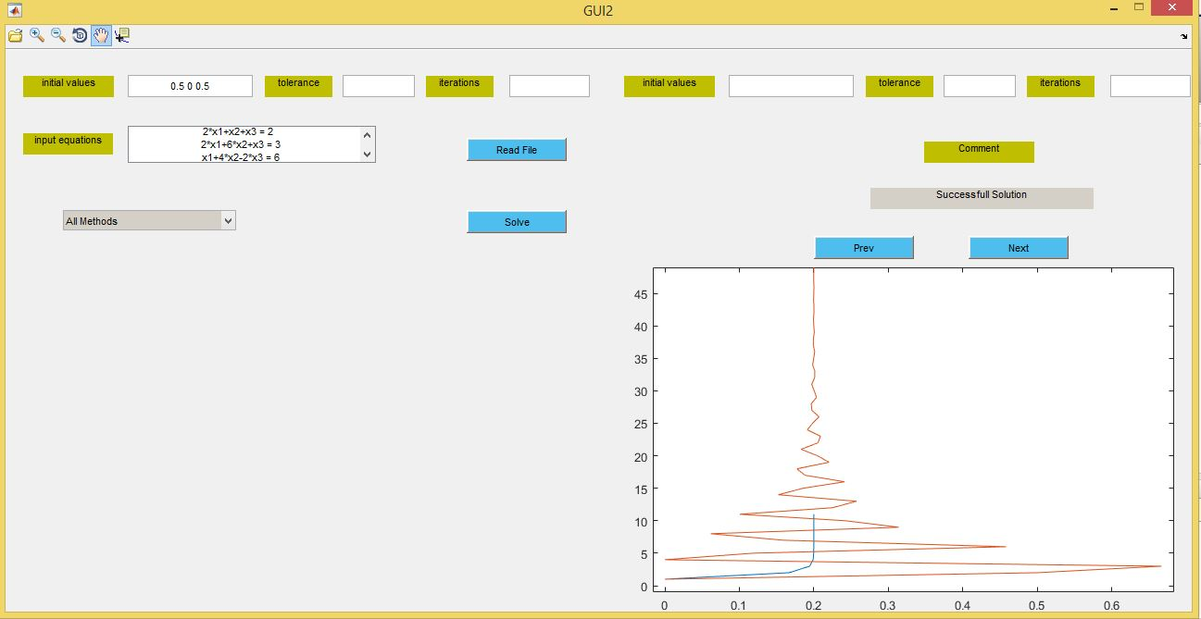

Curve for x3

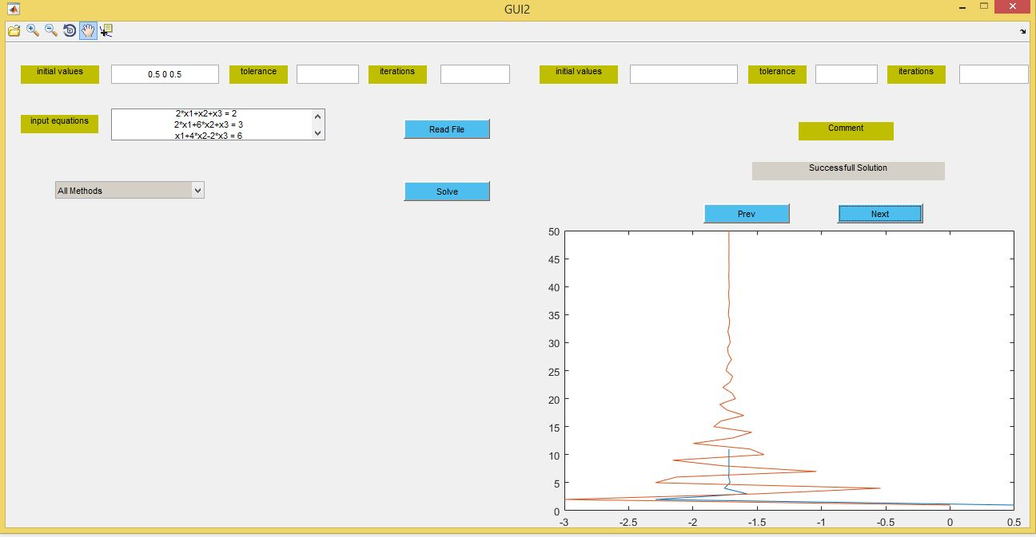

The output Files :

* Gauss Elimination File :

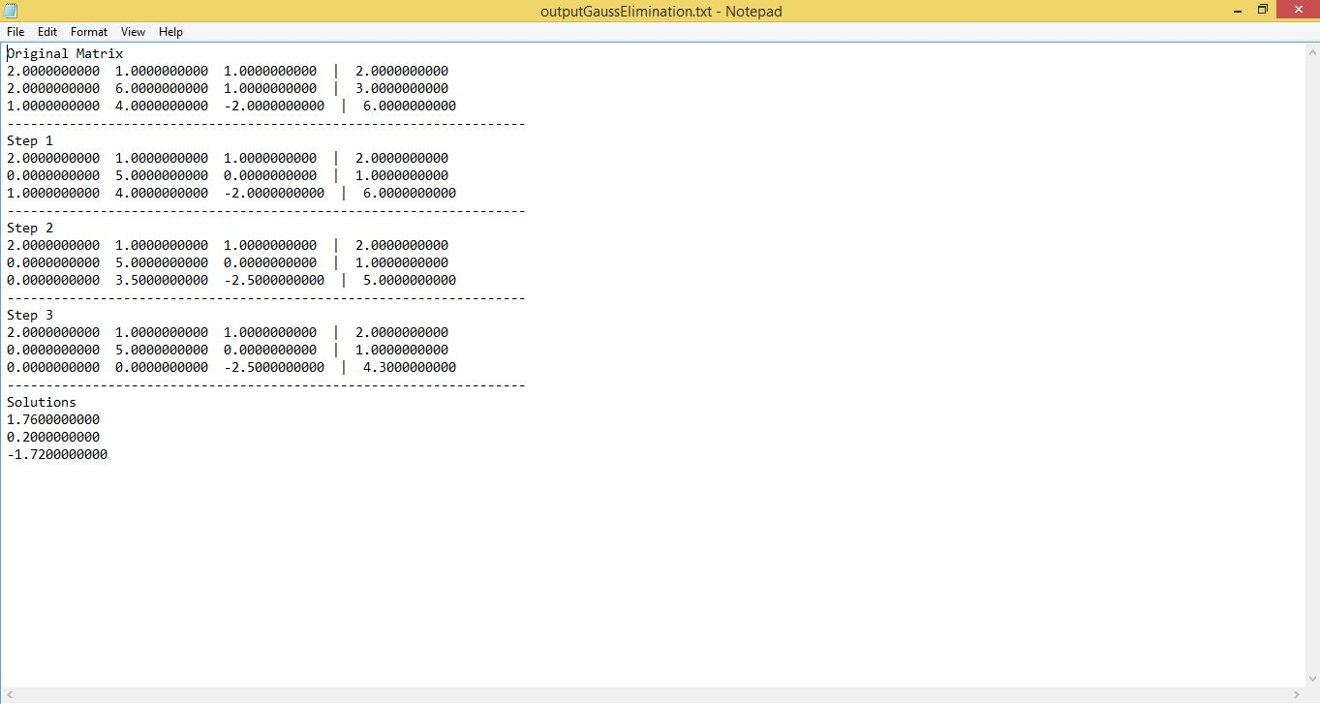

* Gauss Jordan File :

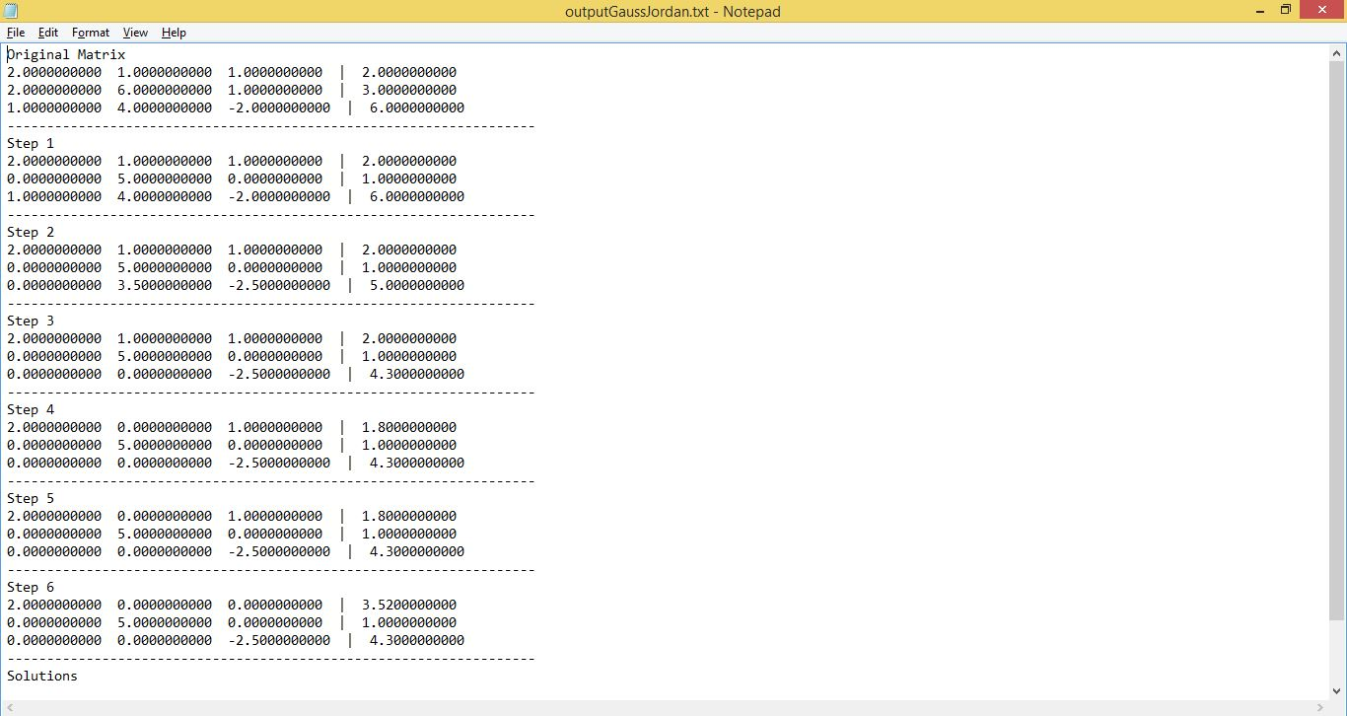

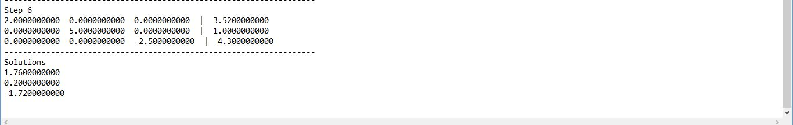

* LU Decomposition File :

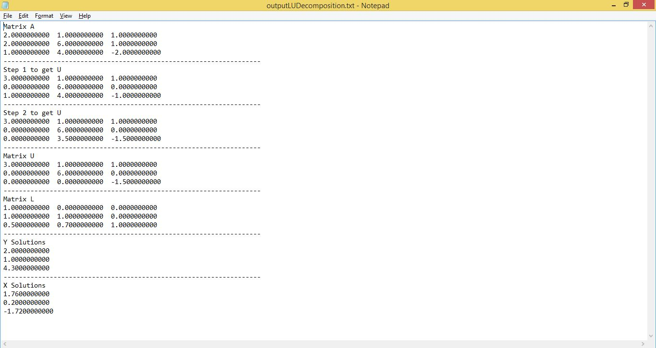

* Gauss Seidel File :

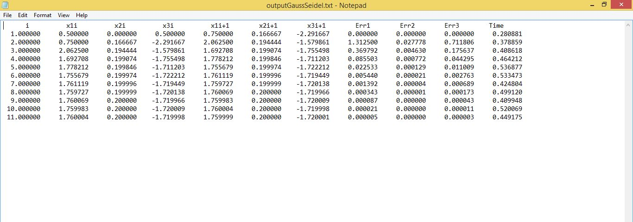

* Jacobi Iterative File :

